Assignment 1

#include <iostream>

using namespace std;

int main() {

cout<<"Enter a number: ";

int num=0;

cin>>num;

cout<<"The factor of "<<num<<" include"<<endl;

for(int i=1;i<num;i++)

{

if(num%i==0)

{

cout<<i<<" ";

}

}

}

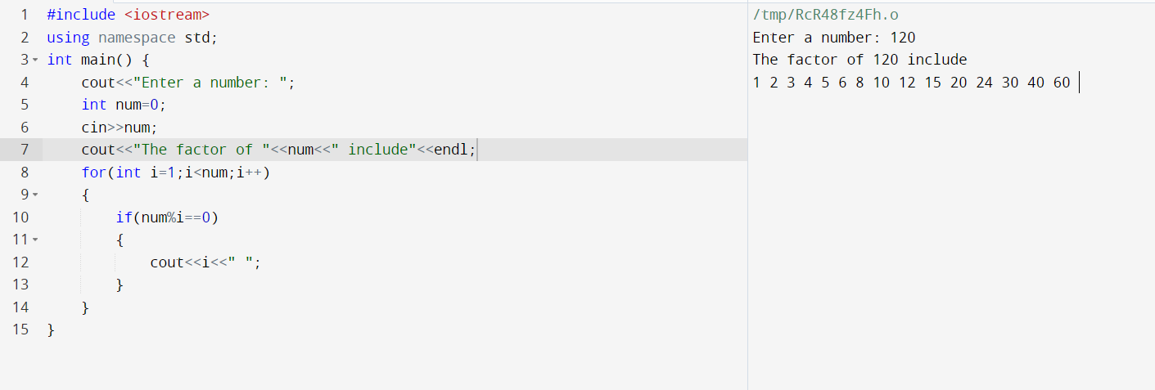

Q2. Write output to the following code;

Answer : x is 5 and y is 10

Q3. Write a C++ program, take an integer value from user and check if it’s greater than 10 and less thanequal to 20. Print 1 if yes and print 0 if no. Use appropriate datatype for output.

Answer :

#include <iostream>

using namespace std;

int main()

{

cout<<"Enter a number : ";

int num;

cin>>num;

if(num>10 && num<20)

{

cout<<"1"<<endl;

}

else

{

cout<<0<<endl;

}

return 0;

}

